

**Talend Documentation**

**Title: Creating a Database Connection**

**Submitted By**

**Tejas Khandale (BDSA210)**

**Vaibhav Mogre (BDSA214)**

**Omkar Kolate (BDSA250)**

**DEPARTMENT OF COMPUTER ENGINEERING**

MIT ACADEMY OF ENGINEERING

ALANDI (D), PUNE

**Prerequisites**

The exercises that need to be done for Database Connectivity we need MS Access 2016 installed on our PC

For MS Access 2016 Connection:

1. Install Talend MDM (7.0.4) with complete packages and proper java environment paths

2. Install modules “ucanaccess-2.0.9.5.jar”, “jackcess-encrypt-2.1.0.jar” and “bcprov-jdk15on-1.5.1.jar” in talend.

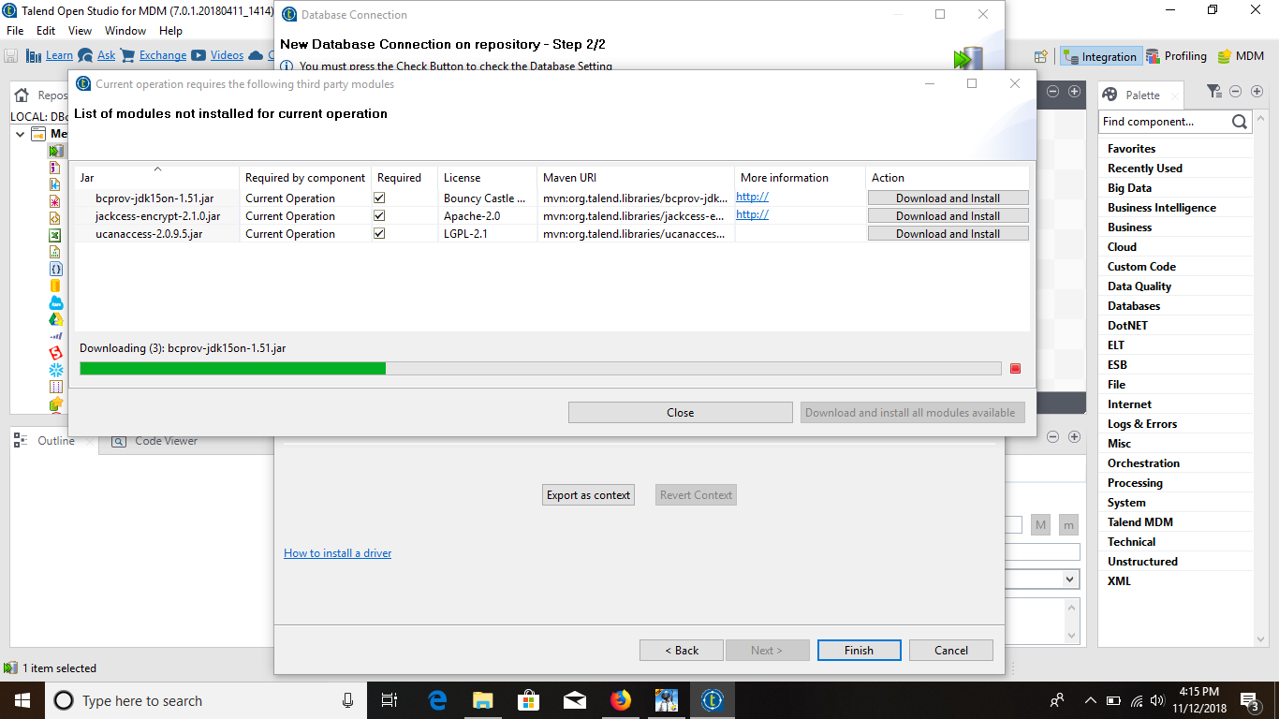

**1. Database**

A **database** is an organized collection of data, generally stored and accessed electronically from a computer system. Where databases are more complex they are often developed using formal design and modelling techniques.

**2. Database Connection using MS-Access**

Steps:

1. Right click Db Connections in Metadata and select Create Connection from it.

2. Two step window will pop up.

Step-1: Fill the different fields like name, purpose and description.

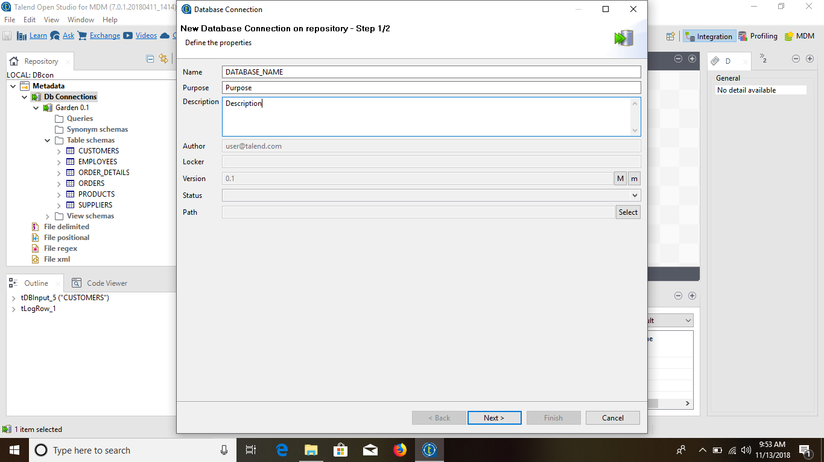

Step-2: Fill the Login Details of the Database and provide with the Location of the Access File.

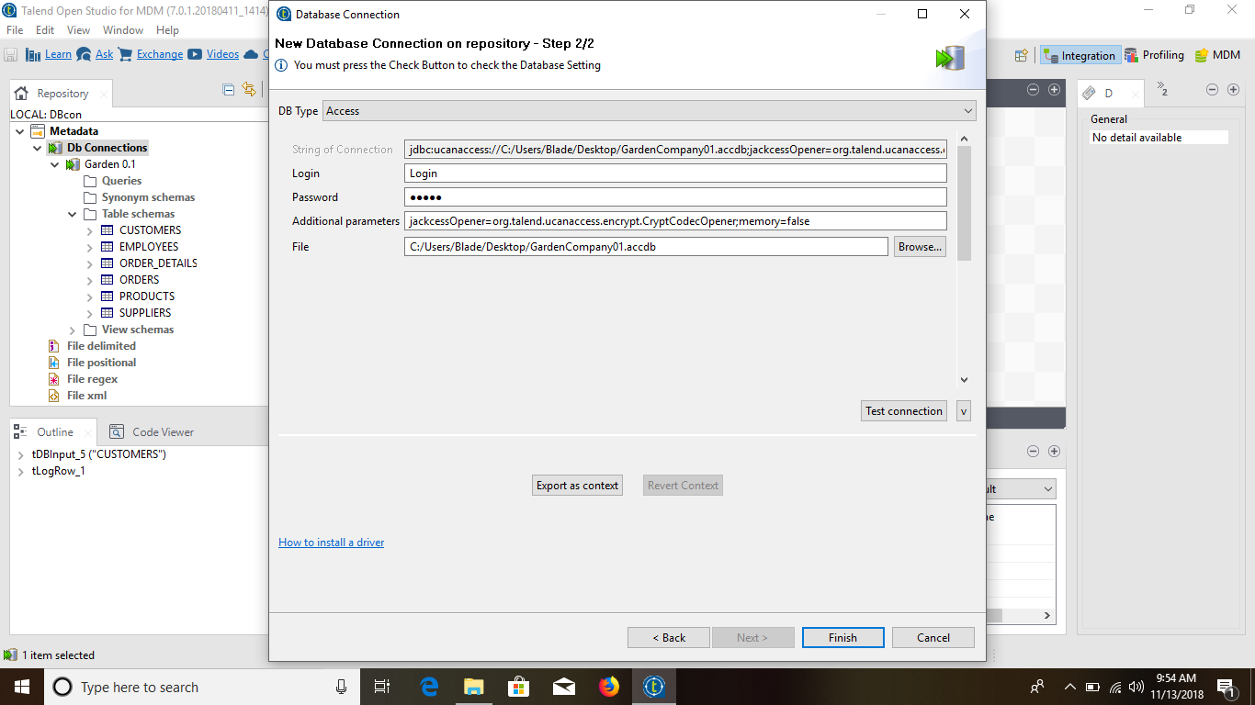

3. Your Database Connection is created.

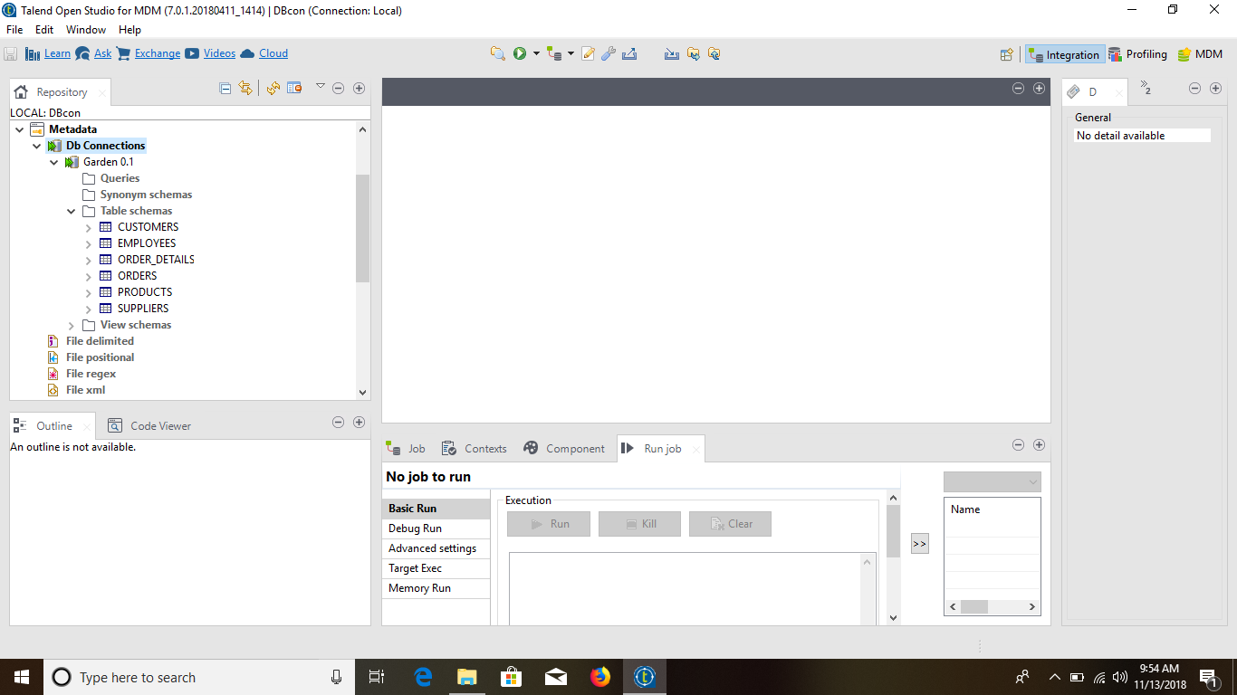

4. Create a Job

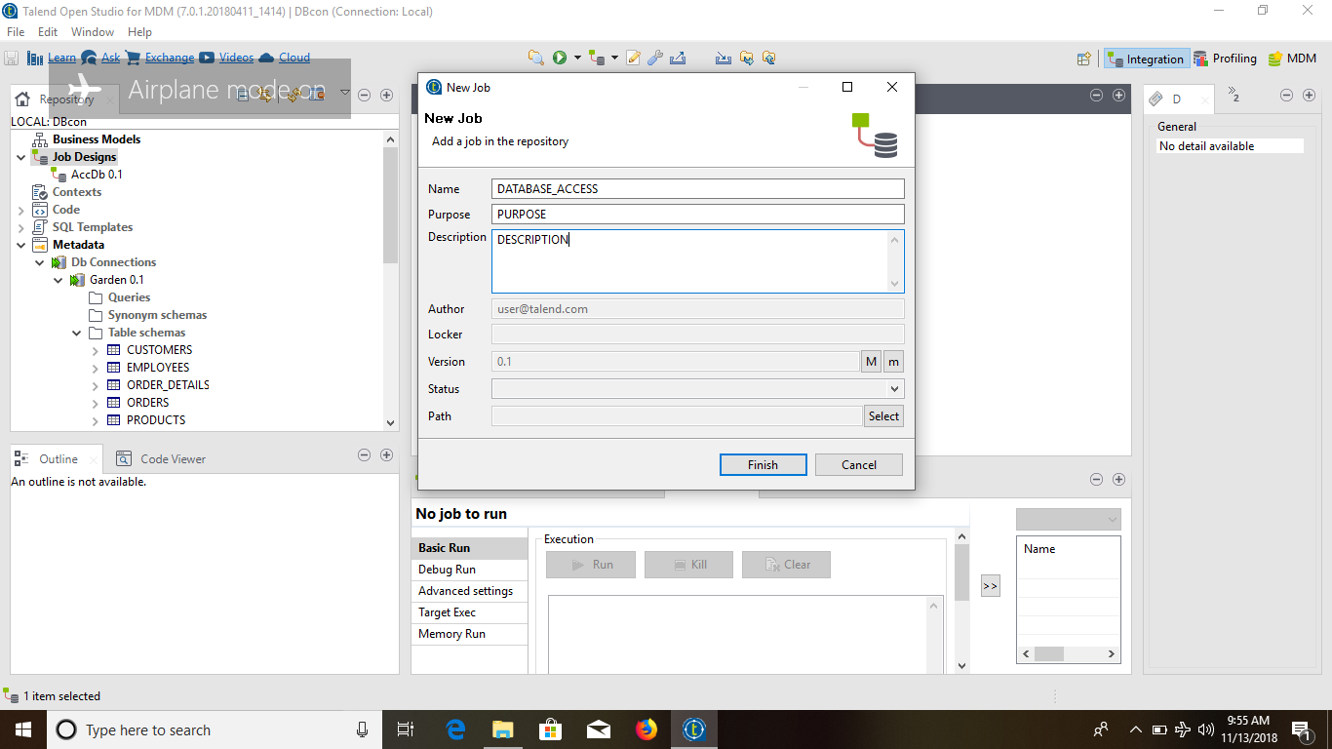

5. Retrieve the Schema

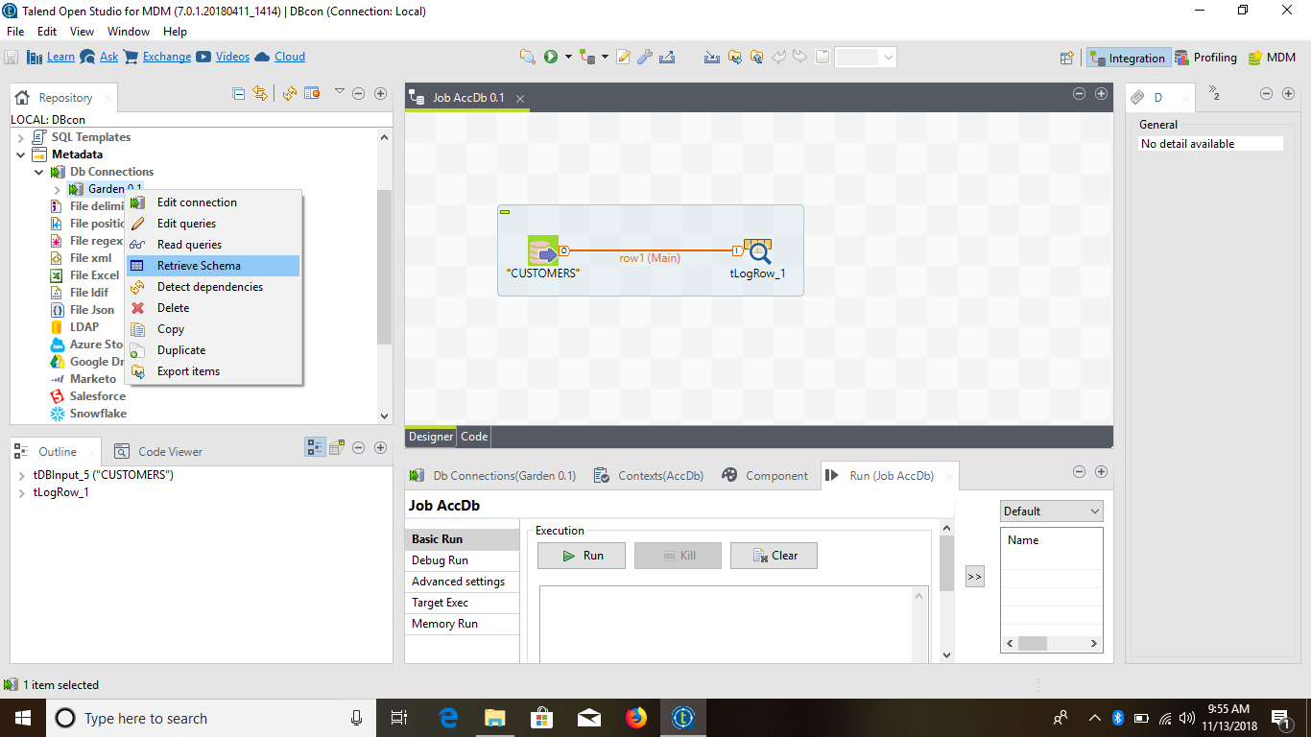

6. Two step window will pop up.

Step-1: First Window is for Advance Filtering which we will be keeping as it is.

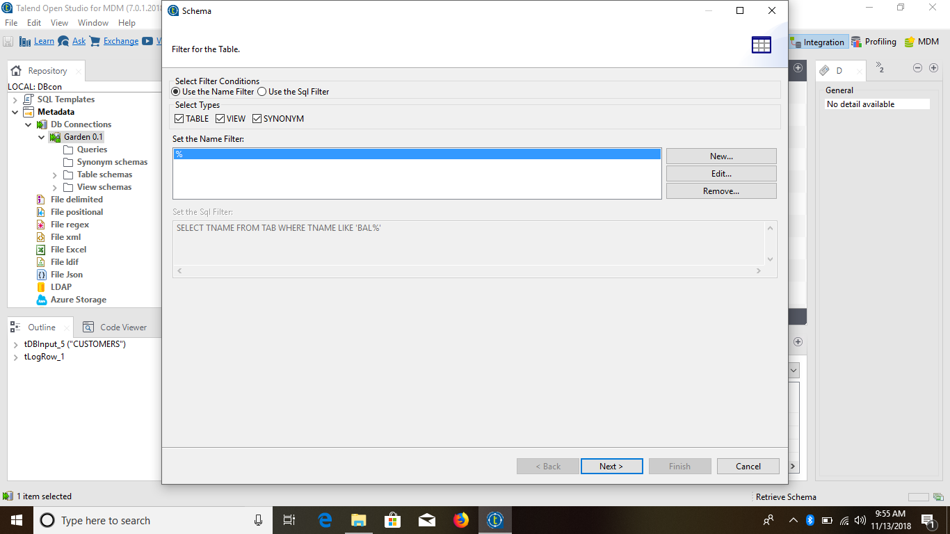

Step-2: Select the tables which are required

Click on “Check Connection” to be sure.

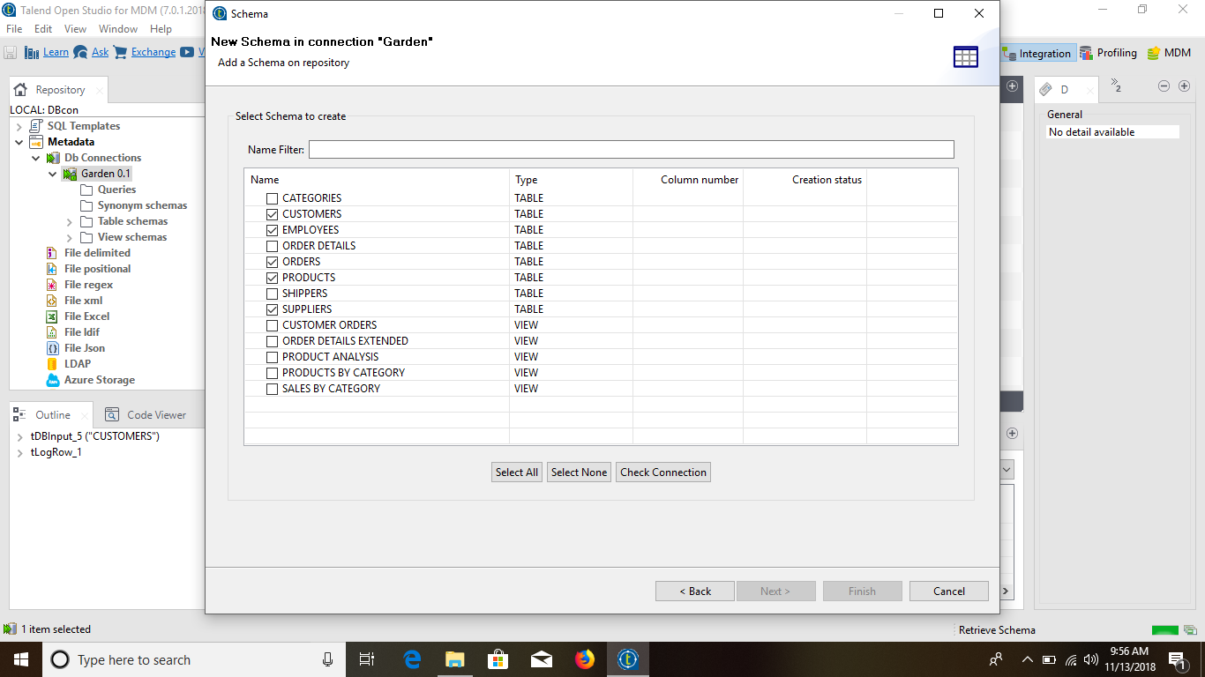

7. Now that Connection is done completely we can start working on that. In the repository panel we can see all the tables that we have done the connection with.

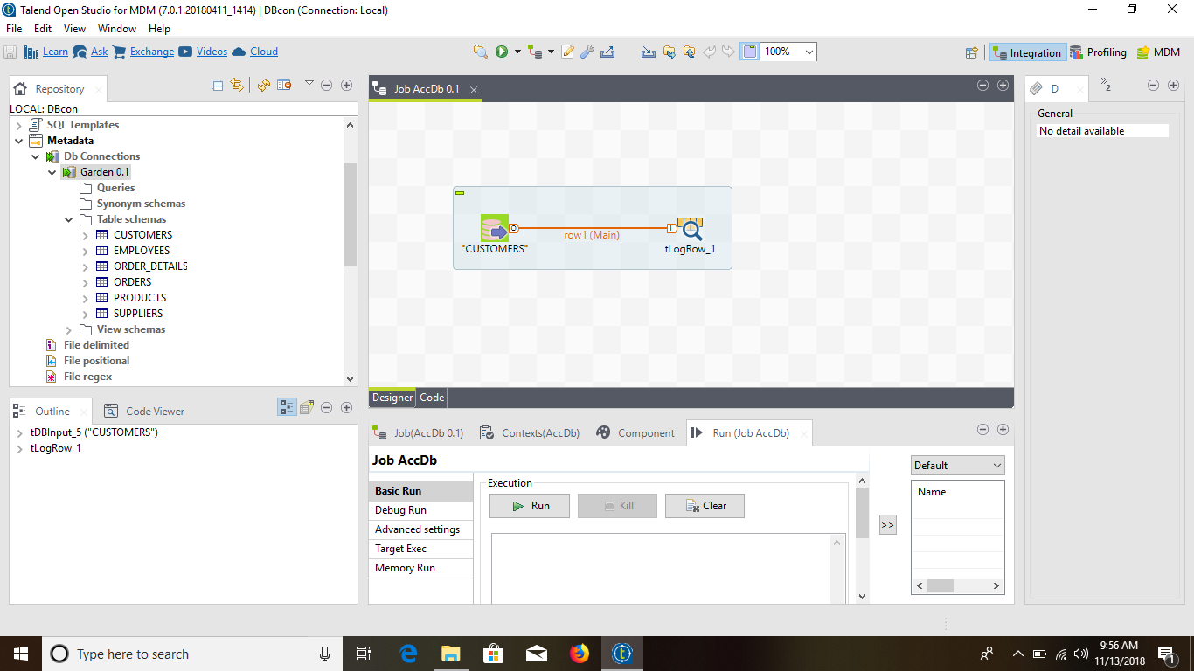

8. Now we have retrieved all the data from the “Customer” table using tLogRow and all the data of that table is displayed in our Console.



